Tugas join query

1. [SELECT](http://localhost/phpmyadmin/url.php?url=https://dev.mysql.com/doc/refman/8.0/en/select.html) id_jenis_obat, nama_obat, obat.id_jenis_obat, id FROM `obat` JOIN jenis ON obat.id_jenis_obat = jenis.id ORDER BY id_jenis_obat DESC;
2. [SELECT](http://localhost/phpmyadmin/url.php?url=https://dev.mysql.com/doc/refman/8.0/en/select.html) id_jenis_obat, jenis_obat, nama_obat, obat.id_jenis_obat, id FROM `obat` JOIN jenis ON obat.id_jenis_obat = jenis.id ORDER BY id_jenis_obat ASC;
3. [SELECT](http://localhost/phpmyadmin/url.php?url=https://dev.mysql.com/doc/refman/8.0/en/select.html) id_jenis_obat, jenis_obat, nama_obat, obat.id_jenis_obat, id FROM `obat` [right](http://localhost/phpmyadmin/url.php?url=https://dev.mysql.com/doc/refman/8.0/en/string-functions.html%23function_right) JOIN jenis ON obat.id_jenis_obat = jenis.id ORDER BY id_jenis_obat ASC;
4. [SELECT](http://localhost/phpmyadmin/url.php?url=https://dev.mysql.com/doc/refman/8.0/en/select.html) tanggal_penjualan, jumlah, stock, penjualan_obat.nama_obat, id_nama_obat FROM `detail_penjualan_obat` [LEFT](http://localhost/phpmyadmin/url.php?url=https://dev.mysql.com/doc/refman/8.0/en/string-functions.html%23function_left) JOIN penjualan_obat ON detail_penjualan_obat.id_nama_obat = detail_penjualan_obat.id_nama_obat ORDER BY id_nama_obat ASC;
5. [SELECT](http://localhost/phpmyadmin/url.php?url=https://dev.mysql.com/doc/refman/8.0/en/select.html) tanggal_penjualan, jumlah, stock, penjualan_obat.nama_obat, id_nama_obat FROM `detail_penjualan_obat` [LEFT](http://localhost/phpmyadmin/url.php?url=https://dev.mysql.com/doc/refman/8.0/en/string-functions.html%23function_left) JOIN penjualan_obat ON detail_penjualan_obat.id_nama_obat = detail_penjualan_obat.id_nama_obat ORDER BY tanggal_penjualan ASC;

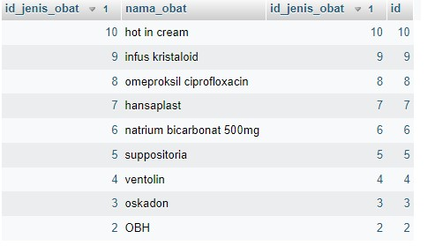 1.

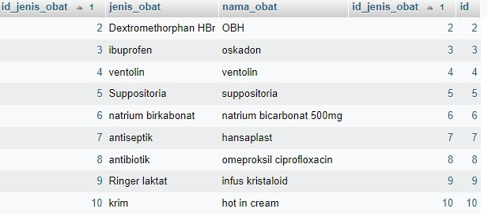2.

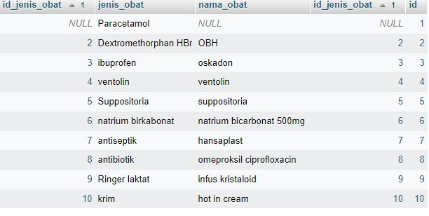3.

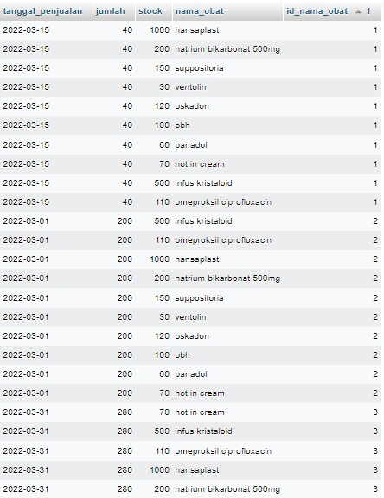

4.

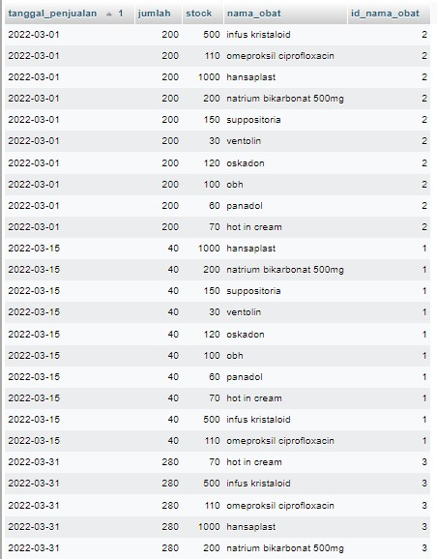 5.